SAINT PETER’S MINI-MAG
St Peter’s Church
The Lawn
Budleigh Salterton EX9 6LT February 2024
Editor: Lizzy Doorbar

A MESSAGE FROM THE REVD. MARTIN JACQUES
Dear Friends,
The most significant events happening this February (apart from my birthday of course!) are both happening on the same day. The 14th February is both Valentine’s Day and Ash Wednesday, the start of the season of Lent. Actually the 14th February was also my nan’s birthday, but hey, less about birthdays and more about the other reasons this day is significant.
I expect a lot of people are a bit sniffy about Valentine’s Day as just another bit of commercial overreach, but he was a real character, a priest, who was executed by Emperor Claudius in about 269AD. His connection to lovers is a little sketchier however, possibly because this was the day in Medieval folklore when birds mated, or perhaps linked to the pagan Lupercalia festival in Rome! Whatever the real reason, Christians can celebrate an all-loving God who blesses those who love one another.
As I say this is also the start of Lent, a season of reflection and contemplation that precedes the festival of Easter. Traditionally this was connected with fasting and austerity (though nowadays just as many people take something up as give something up). There is method in our madness, however. If it is a fact that you enjoy the highs even more when you have been low, then it makes sense to have a great feast time preceded by a more sombre austere period.
Of course, in Latin Catholic countries especially, the beginning of Lent is preceded by one great last Hurrah on Shrove Tuesday known as Mardi Gras in New Orleans or simply Carnival in Brazil. In more sober colder Northern climes such as ours of course we simply have pancakes! But however we choose to celebrate we are all celebrating the same thing – the last day before the start of Lent which itself is a preparation for Easter.
Love and peace,

January 100 Club Draw results
£5 George Lisle £10 Alison Newson. £20 Anne Marshall (for Sam)
Celebrations all round – all the tickets have been sold! Fiona Hennah
Salterton Drama Club
Our next production is “Boeing Boeing”, a very funny and fast-moving farce by Marc Camoletti. Performances at 7.30pm every night between Monday 4th and Friday 8th March with a matinee at 2.30pm on Saturday 9th March. Tickets £14.00 are on sale from February 5th through our website; Ticket Source or Budleigh Information Centre. Judith Stewart-Young

The Loaves and Fishes Christmas Lunch
This was held on 14th December, with festive tables, crackers and chocolates. Jennie and her helper cooked a turkey roast with all the trimmings, and we had coffee and After Eight mints to finish. Tesco Supermarket kindly contributed to the Chocolate Oranges that everyone received, and also gave a hamper to our Raffle, held at the end of the meal, the proceeds going to the Motor Neurone Disease Society. Mary Jones

New Year Restock - news from Exmouth Food Bank
We are anticipating that the increase in demand for our services will continue during the next quarter and now need to focus on replenishing our core stock. We would really appreciate donations of the following items: longlife milk, breakfast cereals, tinned soups, bakedbeans, tinned spaghetti, tins of vegetables, tins of meat and fish, jars of pasta sauce, packets of rice, custard, rice pudding and tins of fruit. Donations can be left in church or any of the three Budleigh supermarkets.
Sue Low
A Little Something
Lent begins with Ash Wednesday on 14th February which this year coincides with Valentine’s Day. Maybe Lent fills you with dread but what if we saw it as a ‘love-gift’ from God? Less about giving up wine and chocolate and more about focussing how we can draw closer to God and experience more of his love, the love which led him to the cross – and beyond. Jean Burrows

St Peter’s School Christmas Service
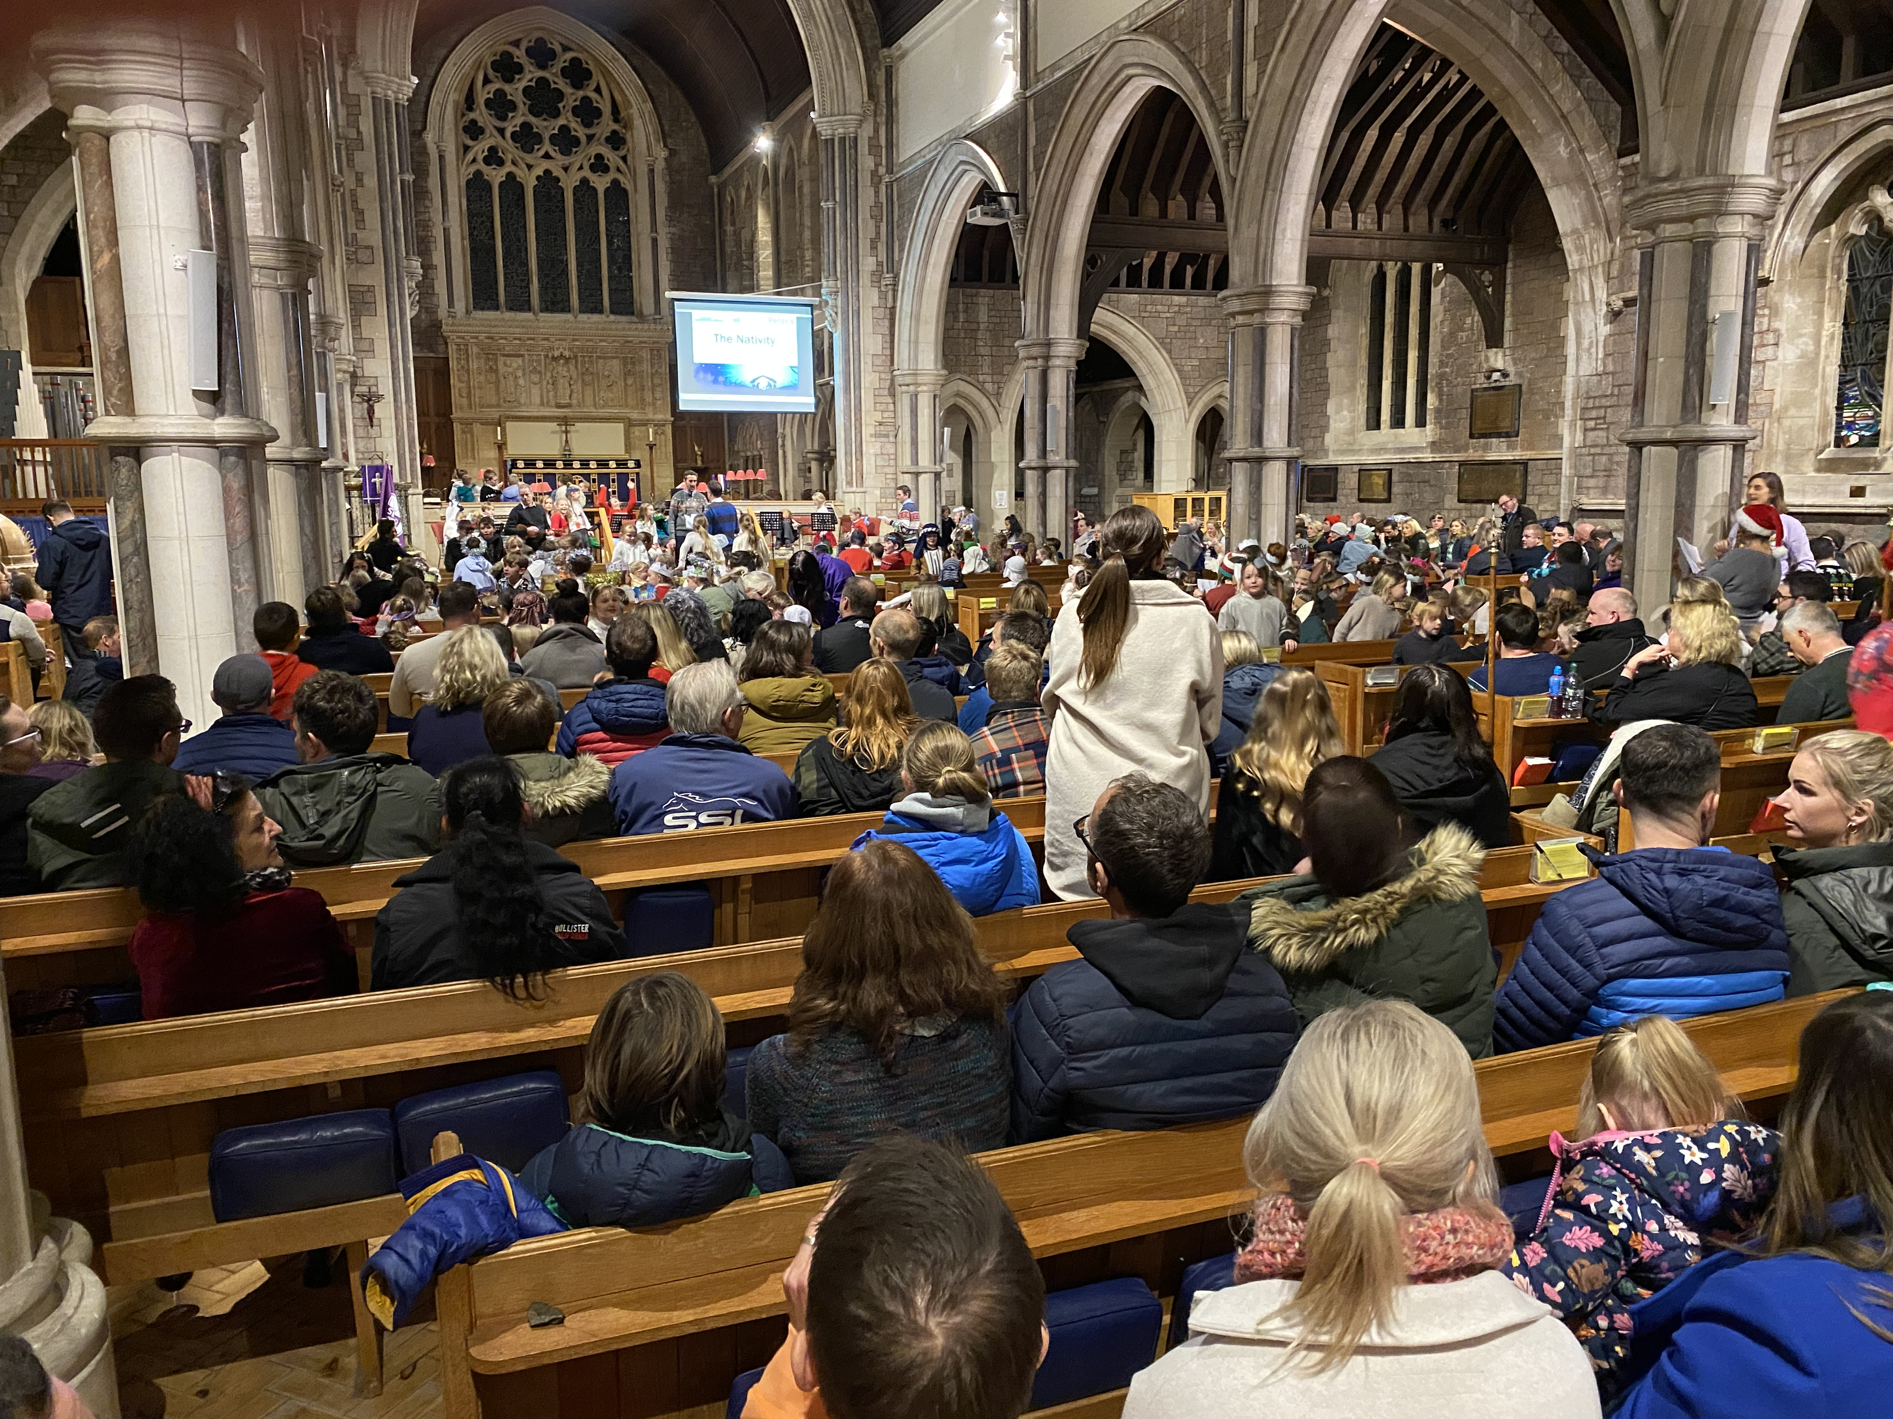
Christmas seems a long time ago now, but it is good to enjoy these pictures of a church filled to the rafters with children and parents! Pat Rogers

Mother’s Union
Thirty people enjoyed the annual lunch on 9th January. £54 was raised by the raffle which will go to Mother’s Union local charities. Our next meeting is on Tuesday 13th February at 2.30 pm in the Peter Hall, when we have our AGM followed by Penny Franklin speaking about the Chaplaincy at the R D & E hospital. This promises to be very interesting and visitors are welcome. Rosemary Baker
Open the Book

Our first story of the new term was Jesus healing the centurion’s servant. Otterton church is very cold in the winter so we’re going to be in school until the weather warms up which is much more comfortable for all of us. For the past year St Peter’s school has had two presentations, Key Stage One and Key Stage Two, but now they are having the whole school together for collective worship, so we have only one presentation in the afternoon. All the children were very attentive, and we enjoy our time with them. Jean Burrows

People in our church: Janice Brace

Janice has lived in her house in Swains Road for forty-seven years, but her early life was largely in and around London. She worked for London and Manchester Assurance Company in the mortgage department. She found the work interesting, and being in central London there were opportunities at lunchtimes. For example, she and some other girls went to see the Lord Mayor’s Show, running as fast as they could in their high heels so as not to be too late back in the office.

She met her future husband Bernard at work. They were married in 1966 and moved to Bishops Stortford, being the best place to afford a house at the time. Rachel and Simon were born, and later the family moved to Budleigh as the company had relocated to Clyst St Mary.

Janice went to St Peter’s Church, and she has clear memories of the Reverend Cheverton’s wife Joyce standing in the pulpit, talking about religious pictures she had painted - maybe other members of the congregation have similar memories? Janice became involved with the Wives Group which had been started by Canon Parry’s wife, Barbara. After a year or so Janice became a member of the committee and remained so for twenty years. Many events were organised, including ‘Blind Date’ (photos of Janice’s husband Bernard and Pat Rogers exist…). It was a lot of fun! During Canon Parry’s time, Janice and other adults were confirmed in St Peter’s, an event which held a lot of meaning for her.

After the children were born Janice did not work for some years, but later took a part-time job at Symes, Robinson and Lee, a firm of solicitors at the traffic lights in Budleigh where she looked after the accounts, the Abbey National Agency and the weekly wages in cash! Another job she enjoyed. She also worked at East Budleigh General Store for a short while, and later when Bernard did consultancy work at home Janice would type up his reports.

Bernard was a founder member of the Budleigh Salterton Lions Club, and both he and Janice enjoyed all the activities for many years – lovely times! Janice is pleased to still be invited to Lions social events. When Bernard retired, they travelled a good deal; people said, ’Are you going away again?!’

Janice has been joint Captain of the Bowls Club, and secretary of Budleigh Chamber of Commerce for several years, following on from Doris Godfrey in that role. While her children were at St Peter’s School, she was a member of the PTA and Chair for her last year. The main fundraising efforts over several years were to provide indoor toilets. This was at the time when George Lisle (a member of our choir) was headteacher. She enjoys painting and spending time with her grandchildren.

Janice has continued to be involved in a wide variety of church matters, including being on the cleaning rota in past years. She remembers the struggle with vacuum cleaners for which the extension lead was not long enough! More recently she has joined the Open the Book team, regularly visiting our local schools with bible stories, which the children love. She is also a member of the knitting group, whose annual display of knitted blankets in aid of CR2EE (Christian Response to Eastern Europe) takes place in East Budleigh Church. She has led, and is leading, a very busy life!

DIARY DATES FOR FEBRUARY
Tuesday 6th 9.30 am : St Peter’s Prayer Group in the Lady Chapel
Thursday 8th 12.15 pm : Loaves & Fishes lunch, Peter Hall. Book with Fran, or Mary Jones on 443333 by six days in advance . Cost £10.
Sunday 11th 6 pm : Choral Evensong
Tuesday 13th 2.30pm : Mothers’ Union AGM followed by talk by Penny Franklin ‘The chaplaincy at the R D & E Hospital’
Tuesday 13th 5.30 pm : Julian Group at 7 Exmouth Road, Budleigh EX9 4AF
Thursday 15th 8.45 am : Men’s Breakfast, Seachange. Book on 443333 three days in advance
Thursday 22nd Dinner at The Holt, at the Cricket Club. More details later
Friday 23rd 9 am – 1 pm : Food Market and Craft Fair in the Public Hall
Sunday 25th 12.15 pm : Solos Lunch. Book with Fran by the previous Wednesday
Rendezvous Café every Friday at 10 am in the Peter Hall

SERVICES
Sundays Holy Communion at 8 am and 10 am Choral Evensong 6 pm second Sunday
Wednesdays Holy Communion at 9.30 am
For services at the other RMC churches see www.raleighmissioncommunity.org.uk

QUICK CONTACTS
VICAR: The Revd. Martin Jacques, The New Vicarage, Vicarage Road, East Budleigh, EX9 6EF. 443473
revmartinjacques@gmail.com (not Fridays)
RMC Administrator: Fran Mills raleighmc@gmail.com Working at home Mon, Tues, Thurs 9 - 1 07880 331465
Working in RMC Office Weds 10.00 – 12.00, Friday 10.00 – 2.00 443397
Churchwardens: Iris Cooper 445273 John Rockey 445520
Deputy Wardens: Judith Stewart-Young 442197 George Maddaford 446077
Pat Rogers 446304 Eileen Milne 446725
Angie McKenna 911243
PCC Secretary: Fran Mills 07880 331465 PCC Treasurer: Tony Gray 444006
Director of Music & Organist: Stephen Tanner 07804 209226 Peter Hall Manager: George Maddaford 446077
St Peter’s Burial Ground: Milena McClellan 445366 Safeguarding Representative: Tina Ellett 07426 090311
Friends of St Peter’s: Co-ordinator Tony Gray 444006 stpetersbudleightreasurer@gmail.com

To join the Mini-Mag email list, please send your address to Lizzy Doorbar at doorbars@btinternet.com
Contributions to the Mini-Mag are most welcome. Please send them to me by 20th of the month. The earlier I receive your piece, the greater the chance of it finding space in the Mini-Mag!

